

**1.6 HYDRAULIC SAFETY**

1. **CAUTION** The hydraulic system is under high pressure.
2. Ensure that only high-pressure hoses are used to connect supply to the Aerator’s hydraulic cylinder. Check hoses regularly and renew any that are damaged or worn.
3. Before working on the hydraulics lower the side pods, release the pressure from the system and stop the tractor engine.
4. **ALWAYS** keep the safe distance (of at least 3m) away when the rams are being lowered.
5. When connecting hydraulic rams make sure that the hydraulic hoses are coupled correctly. Pressure should be released from the system both on the tractor and on the implement side prior to coupling the hoses to the tractor hydraulics.
6. **CAUTION** Hydraulic oil forced out under pressure can break the skin and cause severe injury. In the event of a hydraulic oil leak stop the tractor flow immediately. **DO NOT PUT HANDS NEAR A LEAKING PIPE.**
7. Lubricate the hydraulic cylinders daily when Aerator is not in use as any exposed chrome may start to deteriorate.



**5ft, 8ft, 10ft & 16ft PASTURE AERATOR**

**Operators Manual**

**DECLARATION OF CONFORMITY**

CONFORMING TO EC Machinery Directive 2006/42/EC

We

Fleming Agri-Products Ltd

Newbuildings Industrial Estate

Newbuildings

Northern Ireland

BT47 2SX

Declare in sole responsibility, that the products

Type: 5ft, 8ft, 10ft and 16ft Pasture Aerator

To which this certificate applies, conforms to the basic safety and health requirements of the Machinery Directive 2006/42/EC, and the Transposed Harmonised Standard: BS EN 4254-1 (2015)

Jonathan Lecky

Production Director

**Fleming Agri-Products Ltd**

**Newbuildings Industrial Estate**

**Newbuildings**

**Northern Ireland**

**BT47 2SX**

**Tel: (028) 7134 2637**

**Fax: (028) 7134 4735**

**Email: info@fleming-agri.com**

**www.fleming-agri.com**



*‘****Quality, Strength & Personal Service’***

**1.4 GENERAL OPERATING INSTRUCTIONS**

1. This Aerator is a tractor-mounted farm implement.
2. Ensure the Aerator is correctly and securely attached to the operating vehicle using the

standard 3-point linkage with the lift arm pins provided.

1. From the raised transport position lower the Aerator into the ground. Ground conditions will affect blade penetration. Additional weights may be added to the carrier tray of the Aerator to effect deeper penetration.
2. The angle of the Aerator rotors may be adjusted from 0o through 5o to 10o by repositioning the pillar block bearings using the bolt holes at the outer and inner ends of the rotor shafts. Observe safe practices outlined in section 1.5 when adjusting bearing position. Note that both bearings should be repositioned together to give the correct angle. Also note the orientation of the pillar block bearings. The long collar of both rotor bearings should point away from the centre of the Aerator.

**1.5 MAINTENANCE**

1. As a rule, disengage the driving system, and stop the tractor engine prior to carrying out maintenance, servicing, cleaning or repair work. **ALWAYS** remove the ignition key.
2. Prop the Aerator with appropriate supports before carrying out any adjustments or maintenance.
3. The manufacturer will not be responsible for any damages or injuries caused by unauthorised repair, alterations or mishandling of the Aerator.
4. Maintain the product with care. Check periodically for damage that would affect the safe operation of the Aerator.
5. **ALWAYS** ensure all warning stickers are kept clean and in good condition.
6. Blade bolts **MUST** be checked daily.

This manual is provided to assist you in getting the best results from your Aerator and ensure that you do so safely. If you have any queries about the use of the Aerator contact your dealer before use. Please keep this manual for future reference.

**1.1 FUNDAMENTAL PRECAUTIONS**

On delivery, your dealer gave you an explanation of the operation and maintenance of this Fleming Aerator. Please read and understand these operating instructions before operating the machine for the first time. It is essential that you observe all safety instructions.

Incorrect use or mishandling of the Aerator can endanger:

1. Life and Limb of the operator, other persons or animals standing within the vicinity of the Aerator.
2. The Aerator and other material assets of the owner or third persons.
3. The performance of the Aerator.

Anyone who is involved in the commissioning, operation or maintenance of the Aerator must read and understand the following instructions very carefully and observe them at all times.

**NEVER DISTRACT ANYONE WHO IS USING A MACHINE.**

**1.2 AUTHORISED OPERATORS**

Youths under the age of 16 may not operate this implement. The owner of the Aerator must provide the operator with the operating instructions and make sure they have read and understood them. Only then may the Aerator be put into operation.

The owner must ensure that only authorised persons operate/work on this Aerator. He is responsible for any third persons or animals within the working area of the Aerator.

**A SAFE DISTANCE OF AT LEAST 3M MUST BE OBSERVED BY ANY PERSON OR ANIMAL WITHIN THE VICINITY OF THE AERATOR.**

**1.3 GENERAL SAFETY AND ACCIDENT PREVENTION REGULATIONS**

1. Ensure the Aerator is correctly and securely attached to the operating vehicle. The recommended method of attachment is to use the three point linkage or 3 P.L.
2. **NEVER** attach to a tractor which would be rendered unstable when the Aerator is operated at its full capacity. Take note of the maximum load permissible on the linkage.
3. Attaching and detaching the Aerator to a tractor must be carried out by only one person. There should not be any other persons in the vicinity of the Aerator or tractor.
4. **NEVER** attempt to move the Aerator manually.
5. Before operation make yourself familiar with all elements and controls of the Aerator as well as their functions.
6. Before operation inspect the area around you. Keep children away. All visitors should be kept away from work area.
7. **Under NO Circumstances should anyone attempt to use the Aerator as means of personal transport. It is designed as a special purpose farm implement and is unsuitable for the safe transportation of passengers. NEVER allow anyone especially children to travel anywhere between the tractor and the Aerator.**
8. **NEVER** allow children to play on or around tractors and machinery.

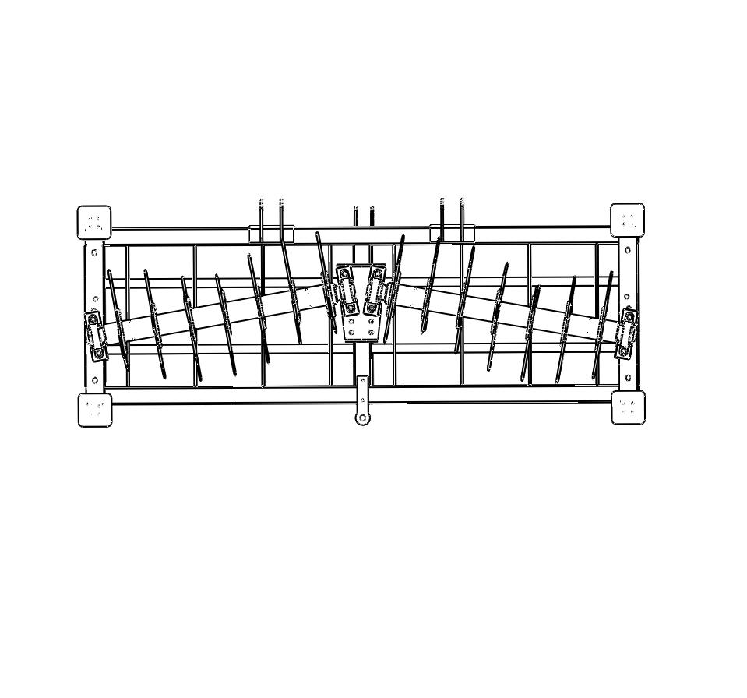

Move both bearings together to obtain angle.

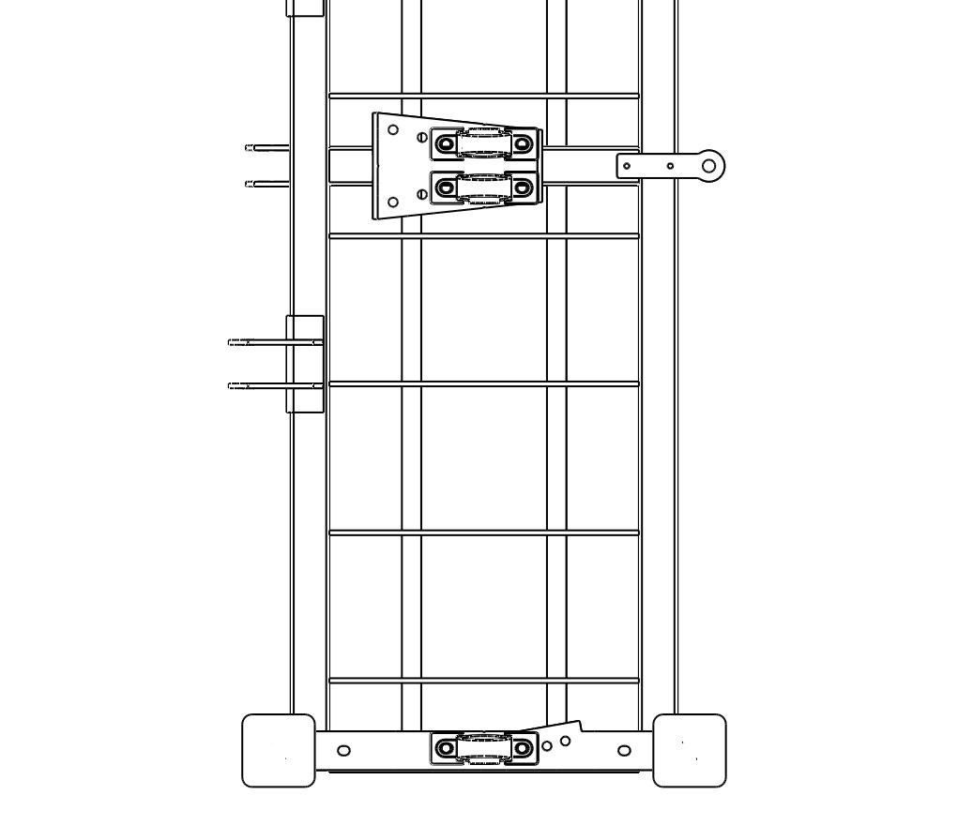

Long collar

Note: Long collar of bearings should point away from centreline of Aerator.

